Supplementary file 1: Appendices
Appendix A
Test and filler sentences in Experiment 1: 8 test sentences including 4 conditional donkey sentences (1-4) and 4 relative-clause donkey sentences (5-8); 8 filler sentences including 4 sentences (9-12) under the conditional donkey sentence condition and 4 sentences (13-16) under the relative-clause donkey sentence condition.

- Ruguo nongfu yang-le gou, ta jiu dai ta qu gongyuan.
if farmer raise-ASP dog he then take it go-ASP park
‘If a farmer owned a dog, he took it to the park.’
- Ruguo huluwa jian-le taozi, ta jiu ba ta songgei-le
if Cucurbita doll pick-ASP peach he then BA it give-to-ASP
yeye.
Grandpa
‘If a Cucurbita doll picked up a peach, he gave it to Grandpa.’
- Ruguo haidao qiang-le jinbi, ta jiu ba ta cangdao-le
if pirate snatch-ASP golden coin he then BA it hide-to-ASP
wuding shang.
roof above
‘If a pirate snatched a golden coin, he hid it above the roof.’
- Ruguo yingxiong zhuadao huaidan, ta jiu ba ta songdao-le jingchaju.
if hero catch bad guy he then BA him take-to-ASP police station
‘If a hero caught a bad guy, he took him to the police station.’
- Mei-ge jian-le tangguo de yang dou ba ta huangei-le huitailang.
every-CL pick-ASP Candy DE goat all BA it return-ASP Wolffy
‘Every goat who picked up a candy returned it to Wolffy.’
- Mei-ge zuo-le binggan de meirenyu dou ba ta songgei-le xiaoyu.
every-CL make-ASP biscuit DE mermaid all BA it give-to-ASP Little Fish
‘Every mermaid who made a biscuit gave it to Little Fish.’
- Mei-ge de-le jiangpai de xiongmao dou ba ta songgei-le mama.
every-CL win-ASP medal DE panda all BA it give-to-ASP Mom
‘Every panda who won a medal gave it to Mom.’
- Mei-ge mai-le pingguo de maomaochong dou ba ta songgei-le yaojing.
every-CL buy-ASP apple DE caterpillar all BA it give-to-ASP Spirit
‘Every caterpillar who bought an apple gave it to Spirit.’
- a. Wangbobo yang-le liang-tiao gou. (T)
Wang uncle raise-ASP two-CL dog
‘Uncle Wang raised two dogs.’
b. Sunbobo yang-le yi-tiao gou. (F)
Sun uncle raise-ASP one-CL dog
‘Uncle Sun raised one dog.’
- a. Dawa zai guoyuan li jian-le liang-ge taozi. (T)
Dawa LOC orchard in pick-ASP two-CL peach
‘Dawa picked up two peaches in the orchard.’
b. Siwa zai guoyuan li jian-le yi-ge taozi. (F)
Siwa LOC orchard in pick-ASP one-CL peach
‘Siwa picked up one peach in the orchard.’
- a. Jiekechuanzhang qiang-le liang-ge jinbi. (T)
Captain Jack snatch-ASP two-CL golden coin
‘Captain Jack snatched two golden coins.’
b. heihaidao qiang-le yi-ge jinbi. (F)
Black Pirate snatch-ASP one-CL golden coin
‘Black Pirate snatched one golden coin.’
- a. Zhizhuxia zhuadao-le liang-ge huaidan. (T)
Spiderman catch-ASP two-CL bad guy
‘Spiderman caught two bad guys.’
b. Meiguoduizhang zhuadao-le yi-ge huaidan. (F)
Captain America catch-ASP one-CL bad guy
‘Captain America caught one bad guy.’
- a. Mei-ge meirenyu dou canjia-le bisai. (T)
every-CL mermaid all participate-in-ASP competition
‘Every mermaid participated in the competition.’
b. Mei-ge meirenyu dou zuo-le binggan. (F)
every-CL mermaid all make-ASP biscuit
‘Every mermaid made biscuits.’
- a. Mei-zhi yang dou qu jiaoyou-le. (T)
every-CL goat all go outing-ASP
‘Every goat went for the outing.’
b. Mei-zhi yang dou jiandao-le tangguo. (F)
every-CL goat all pick-ASP candy
‘Every goat picked up candies.’
- a. Mei-ge xiongmao dou canjia-le yundonghui. (T)
every-CL panda all participate-in-ASP sports meeting
‘Every panda participated in the sports meeting.’
b. Mei-ge xiongmao dou de-le jiangpai. (F)
every-CL panda all win-ASP medal
‘Every panda won medals.’
- a. Mei-ge maomaochong dou qu-le jishi. (T)
every-CL caterpillar all go-ASP market
‘Every caterpillar went to the market.’
b. Mei-ge maomaochong dou mai-le pingguo. (F)
every-CL caterpillar all buy-ASP apple
‘Every caterpillar bought apples.’

Appendix B
Test and filler sentences in Experiment 2: 8 test sentences including 4 donkey sentences (1-4) in Context A and 4 donkey sentences (5-8) in Context B; 8 filler sentences including 4 sentences (9-12) in the Context A condition and 4 sentences (13-16) in the Context B condition.

- Meiyou renhe yi-ge yang-le gou de nongfu ba ta dai qu-le gongyuan.
no any one-CL raise-ASP dog DE farmer BA it take to-ASP park
‘No farmer who has raised a dog took it to the park.’
- Meiyou renhe yi-ge jian-le taozi de huluwa ba ta songgei-le
no any one-CL pick-ASP peach DE Cucurbita doll BA it give-to-ASP
yeye.
Grandpa
‘No Cucurbita doll who has picked up a peach gave it to Grandpa.’
- Meiyou renhe yi-ge qiang-le jinbi de haidao ba ta cangdao-le
no any one-CL snatch-ASP golden coin DE pirate BA it hide-to-ASP
wuding shang.
roof above
‘No pirate who has snatched a golden coin hid it above the roof.’
- Meiyou renhe yi-ge zhua-le huaidan de yingxiong ba ta songdao-le
no any one-CL catch-ASP bad guy DE hero BA it send-to-ASP
jingchaju.
police station
‘No hero who has caught a bad guy sent it to the police station.’
- Meiyou renhe yi-ge zuo-le binggan de meirenyu ba ta songgei-le
no any one-CL make-ASP biscuit DE mermaid BA it give-to-ASP
xiaoyu.
Little Fish
‘No mermaid who has made a biscuit gave it to Little Fish.’
- Meiyou renhe yi-ge jian-le tangguo de yang ba ta huangei-le
no any one-CL pick-ASP candy DE goat BA it return-ASP
huitailang.
Wolffy
‘No goat who has picked up a candy returned it to Wolffy.’
- Meiyou renhe yi-ge de-le jiangpai de xiongmao ba ta songgei-le
no any one-CL win-ASP medal DE panda BA it give-to-ASP
baba.
Dad
‘No panda who has won a medal gave it to Dad.’
- Meiyou renhe yi-ge mai-le pingguo de maomaochong ba ta songgei-le
no any one-CL buy-ASP apple DE caterpillar BA it give-to-ASP
yaojing.
Spirit
‘No caterpillar who has bought an apple gave it to Spirit.’
- a. Meiyou renhe yi-ge nongfu yang-le gou. (F)
no any one-CL farmer raise-ASP dog
‘No farmer raised any dog.’
b. Meiyou renhe yi-tiao gou shi Sunbobo de. (T)
no any one-CL dog be Uncle Sun DE-poss
‘No dog belongs to Uncle Sun.’
- a. Meiyou renhe yi-ge huluwa jian-le taozi. (F)
no any one-CL Cucurbita doll pick-ASP peach
‘No Cucurbita doll picked up any peach.’
b. Meiyou renhe yi-ge taozi shi Siwa de. (T)
no any one-CL peach be Siwa DE-poss
‘No peach belongs to Siwa.’
- a. Meiyou renhe yi-ge haidao qiang-le jinbi. (F)
no any one-CL pirate snatch-ASP golden coin
‘No pirate snatched any golden coin.’
b. Meiyou renhe yi-ge jinbi shi Heihaidao de. (T)
no any one-CL golden coin be Black Pirate DE-poss
‘No golden coin belongs to Black Pirate.’
- a. Meiyou renhe yi-ge yingxiong zhuadao-le huaidan. (F)
no any one-CL hero catch-ASP bad guy
‘No hero caught any bad guy.’
b. Meiyou renhe yi-ge huaidan zai silou zuo huai shi. (T)
no any one-CL bad guy LOC fourth floor do bad thing
‘No bad guy did bad things on the fourth floor.’
- a. Meiyou renhe yi-ge meirenyu zuo-le binggan. (F)
no any one-CL mermaid make-ASP biscuit
‘No mermaid made any biscuit.’
b. Meiyou renhe yi-ge binggan shi zimeirenyu de. (T)
no any one-CL biscuit be Purple Mermaid DE-poss
‘No biscuit belongs to Purple Mermaid.’
- a. Meiyou renhe yi-ge yang jiandao-le tangguo. (F)
no any one-CL goat pick-ASP candy
‘No goat picked up any candy.’
b. Meiyou renhe yi-ge tangguo bei lanyangyang jiandao-le. (T)
no any one-CL candy BEI Lazy Goat pick-ASP
‘No candy was picked up by Lazy Goat.’
- a. Meiyou renhe yi-ge xiongmao de-le jiangpai. (F)
no any one-CL panda win-ASP medal
‘No panda won any medal.’
b. Meiyou renhe yi-ge jiangpai shi fenxiongmao de. (T)
no any one-CL medal be Pink Panda DE-poss
‘No medal belongs to Pink Panda.’
- a. Meiyou renhe yi-ge maomaochong mai-le pingguo. (F)
no any one-CL caterpillar buy-ASP apple
‘No caterpillar bought any apple.’
b. Meiyou renhe yi-ge pingguo shi fenmaomaochong de. (T)
no any one-CL apple be Pink Caterpillar DE-poss
‘No apple belongs to Pink Caterpillar.’

Supplementary file 2: Tables and figures

Table 1: Two types of story contexts in Experiment 2
Four goats | Number and distribution of candies among the goats | Number and distribution of candies that were returned to Wolffy by the goats | Number and distribution of candies that were not returned to Wolffy
A | 2 | 0 | 2
B | 2 | 0 | 2
C | 2 | 1 | 1
D | 0 | 0 | 0
Context A—Universal reading: T Existential reading: F
Four goats | Number and distribution of candies among the goats | Number and distribution of candies that were returned to Wolffy by the goats | Number and distribution of candies that were not returned to Wolffy
A | 2 | 1 | 1
B | 2 | 1 | 1
C | 2 | 1 | 1
D | 0 | 0 | 0
Context B—Universal reading: T Existential reading: F

Figure 1: Final scene of the example story

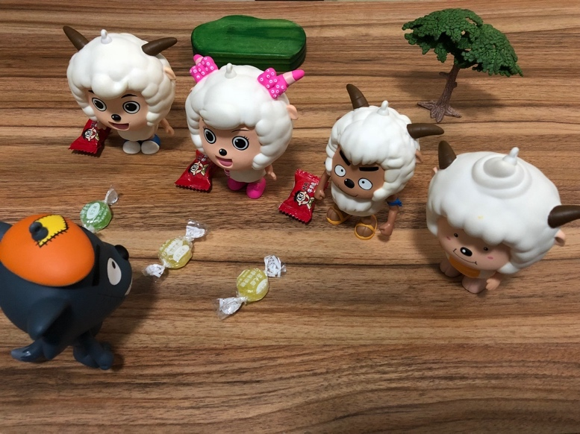

Figure 2: Mean acceptance rates of the conditional and relative-clause donkey sentences by Mandarin-speaking children and adults in UE context; Error bars indicate SEs.

Figure 3: Mean rejection rates of the test sentences in the two types of contexts by Mandarin-speaking children and adults in DE context; Error bars indicate SEs.

